EX4 – CHAT USING TCP
- S. Vishakan CSE – C 18 5001 196

Server Program:

#include <stdio.h>
#include <sys/types.h>
#include <sys/socket.h>
#include <netinet/in.h>
#include <string.h>

int main(int argc, char **argv){
int sockfd, newfd, len, flag, curfd;
struct sockaddr_in server_address, client_address;
char buffer[1024];
pid_t child;

sockfd = socket(AF_INET, SOCK_STREAM, 0); //AF_INET : IPv4 Protocol, SOCK_STREAM : reliable 2-way connection based service
//socket is a file descriptor that lets an applicaton R/W data from/to the network

if(sockfd < 0){ //Error has occurred.
perror("Socket cannot be created.\n");
exit(1);
}

bzero(&server_address, sizeof(server_address)); //Erases the data pointed to in the server_address by writing 0s
server_address.sin_family = AF_INET; //Use the Internet address family, AF_INET : IPv4 Protocol
server_address.sin_addr.s_addr = INADDR_ANY; //IP Address
server_address.sin_port = htons(7229); //Port Number; htons: host byte order -> network byte order, short

if(bind(sockfd, (struct sockaddr*)&server_address, sizeof(server_address)) < 0){
//Binding the socket to the port with server_address
perror("Bind error occurred.\n");
exit(1);
}

printf("Waiting for client...\n");
listen(sockfd, 10); //indicates that server will accept a conection. Parameter 2 indicates backlog (max # of active participants that can wait for a connection)
len = sizeof(client_address);

while(1){ //server is always up
newfd = accept(sockfd, (struct sockaddr*)&client_address, &len);

if(newfd < 0){
printf("Error Occurred\n");
return;
}

if((child = fork()) == 0){ //child process becomes new server
int p_id = getpid();
close(sockfd); //closing sockfd since child doesn't handle it

while(1){ //parent process handles connected client
bzero(buffer, sizeof(buffer));
recv(newfd, buffer, 1024, 0);

if(strcmp(buffer, "!bye") == 0){ //if "!bye" is received
printf("Client %d says: %s\n", p_id, buffer);
printf("Disconnected from Client %d.\n", p_id);
close(newfd);
return;
}
else{
printf("Client %d says: %s\n", p_id, buffer);
bzero(buffer, sizeof(buffer));
printf("Server response: ");
scanf(" %[^\n]", buffer);
send(newfd, buffer, strlen(buffer), 0);

if(strcmp(buffer, "!bye") == 0){ //if "!bye" is sent
printf("Disconnected from Client %d.\n", p_id);
close(newfd);
return;
}
}
}
}

}

close(newfd);

return 0;
}

Output:

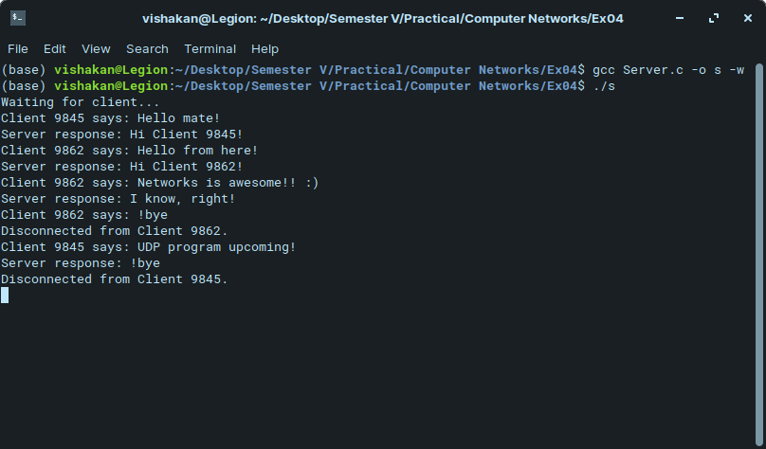
Client Program:

#include <stdio.h>
#include <sys/types.h>
#include <sys/socket.h>
#include <netinet/in.h>
#include <string.h>

int main(int argc, char **argv){
int sockfd, flag, len;
struct sockaddr_in server_address, client_address;
char buffer[1024];
sockfd = socket(AF_INET, SOCK_STREAM, 0);

if(sockfd < 0){ //Error has occurred.
perror("Socket cannot be created.\n");
exit(1);
}
bzero(&server_address, sizeof(server_address));
server_address.sin_family = AF_INET;
server_address.sin_addr.s_addr = inet_addr(argv[1]);
server_address.sin_port = htons(7229);
connect(sockfd, (struct sockaddr*)&server_address, sizeof(server_address));

while(1){ //client disconnects once "!bye" is sent or received
printf("Client says : ");
bzero(buffer, sizeof(buffer));
scanf(" %[^\n]", buffer);
send(sockfd, buffer, strlen(buffer), 0);

if(strcmp(buffer, "!bye") == 0){ //if "!bye" is sent
close(sockfd);
printf("Disconnected from server.\n");
break;
}
else{
bzero(buffer, sizeof(buffer));
len = recv(sockfd, buffer, 1024, 0);
printf("Server response: %s\n", buffer);

if(strcmp(buffer, "!bye") == 0){ //if "!bye" is received
close(sockfd);
printf("Disconnected from server.\n");
break;
}
}
}

return 0;
}

Output:

